1. Download and install visual studio code
2. Download and install most recent version of Git from

<https://git-scm.com/downloads>

Select everything in during the installation.

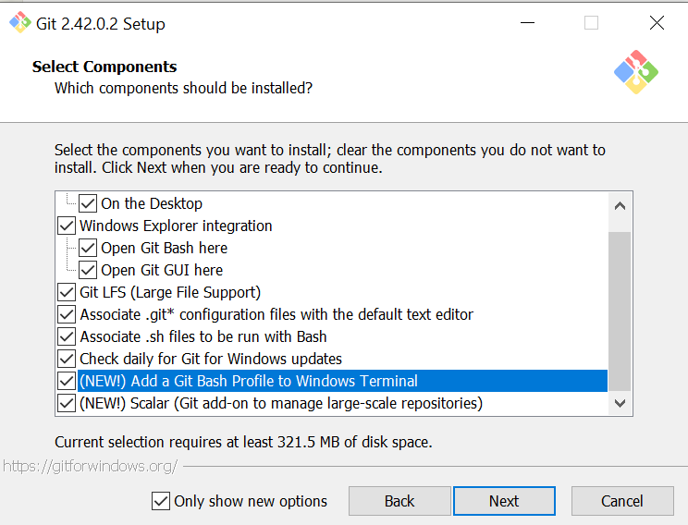

Select subline as the default editor for git

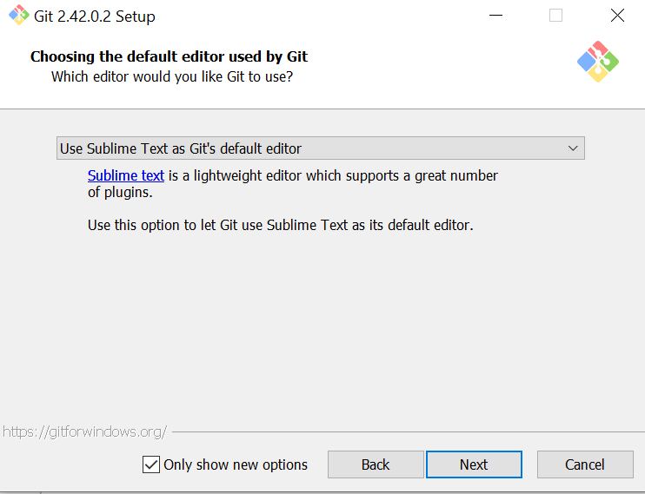

1. Download and install node-v21.1.0 -x64

<https://nodejs.org/en/download/>

1. Install express for node.js

Npm install express --save

1. Install React Native CLI

npm install -g react-native-cli

1. Install React Native

npm install -g react-native

1. Navigate to the parent folder of our target project (for example D:\Zilicon)

D:

mkdir zilicon

cd “Zilicon”

1. Download the files from github to your Zilicon folder

git clone <https://github.com/allenyzhang/LittlePandaApp>

Cd LittlePandaApp

1. Install expo

npm install expo

1. Start project

npx expo start

1. Install expo go on the phone and scan the QR code
2. Setup react-native development with Expo Go (for Allen ONLY!)
   1. Navigate to the parent folder of our target project (for example D:\Zilicon)

D:

mkdir zilicon

cd “Zilicon”

* 1. Create expo project

npx create-expo-app LittlePandaApp

cd LittlePandaApp

* 1. Navigation Setup For navigation between different screens (categories, book lists, and reading mode), you might want to use React Navigation. Install it with:

npm install @react-navigation/native @react-navigation/stack

* 1. Text-to-Speech To enable text-to-speech functionality, you can use the react-native-tts library. Install it with:

npm install react-native-tts

* 1. Start project

npx expo start